**Requirement Gathering and Analysis Phase**

**Solution Architecture**

|  |  |
| --- | --- |
| Date | 06th July 2024 |
| Team ID | SWTID1720075176 |
| Project Name | Project – Online Complaint Registration and Mangament |
| Maximum Marks |  |

**Solution Architecture:**

Solution architecture is a complex process – with many sub-processes – that bridges the gap between business problems and technology solutions. Its goals are to:

* Find the best tech solution to solve existing business problems.
* Describe the structure, characteristics, behavior, and other aspects of the software to project stakeholders.
* Define features, development phases, and solution requirements.
* Provide specifications according to which the solution is defined, managed, and delivered.

**Example - Solution Architecture Diagram:**

The Indian complaint box is designed to serve as a centralized and accessible platform for citizens to voice their grievances and concerns regarding government services, public infrastructure, and community-related issues. This innovative system aims to bridge the gap between the government and the people, empowering citizens to actively participate in the improvement of public service delivery. The complaint submission process on the Indian Complaint Box website is streamlined and efficient. Citizens can log on to the platform and submit their grievances through a simple and straightforward form, providing details about the nature of the issue, the location, and any supporting evidence or documentation. The website's backend is equipped with secure data management protocols to ensure the confidentiality and integrity of the complaint information.  
  
**Flow of the Process:**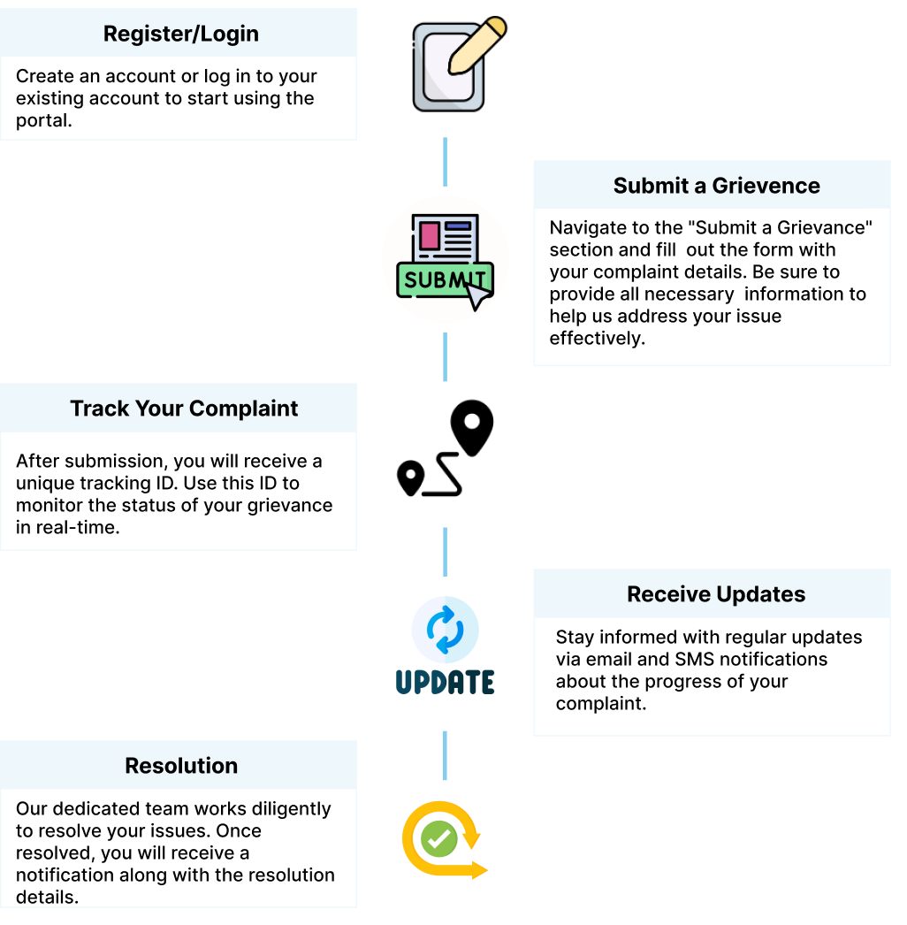

**Features and Functionalities:**

**User Registration and Authentication**: Allow users to register and securely access the complaint management system.

**Complaint Submission**: Provide an intuitive interface for users to submit complaints, including options to upload supporting documents.

**Complaint Tracking**: Enable users to track the status of their submitted complaints, including updates on the resolution process.

**Complaint Resolution**: Facilitate the efficient handling of complaints by government authorities, with clear escalation and notification mechanisms.

**Mobile Accessibility**: Develop a responsive design or a dedicated mobile application to allow users to access the complaint management system on the go.

**Characteristics and Behaviour:**

**User-Friendly Interface**: The website should have a clean, intuitive, and visually appealing user interface that guides users through the complaint submission and tracking process.Efficient **Complaint Handling**: The system should efficiently route complaints to the relevant government authorities, track their progress, and provide timely updates to users.

**Scalable Architecture:** The solution should be designed to handle increasing user traffic, data volumes, and feature requirements without compromising performance or availability.

**User Registration and Authentication:**

Secure registration process with email verification and password management

Role-based access control to manage user permissions

**Complaint Submission:**

Intuitive form-based interface for users to provide complaint details

Ability to upload supporting documents (e.g., images, documents)  
  
**Complaint Tracking:**

Real-time status updates on the complaint resolution process

Notification mechanisms (email, SMS, in-app) to keep users informed

**Complaint Resolution:**

Seamless integration with government agencies' complaint management systems

Feedback and rating mechanisms for users to evaluate the resolution process  
  
Two-Factor Verification

**Development Phases:**

